# 

# Programming for Problem Solving Lab Report

**Name:** Goraksha **Branch:** Electrical Engineering

**Section:** EEA1 **Roll Number:** 2016016

|  |  |  |  |
| --- | --- | --- | --- |
| **S.No** | **PROJECT NAME** | **DATE** | **TEACHER SIGN** |
| 1 | Program to print a content using printf & puts |  |  |
| 2 | Program to use different data types (int, float, char) |  |  |
| 3 | Program to use arithmetic operators |  |  |
| 4 | Program to use logical Operators |  |  |
| 5 | Program to use relational Operators |  |  |
| 6 | Program to use Increment and Decrement Operators |  |  |
| 7 | Program to use If-else, If else ladder |  |  |
| 8 | Program to for loop, nested for loop |  |  |
| 9 | Program to use while loop, do while loop |  |  |
| 10 | Program to use switch (Break & Continue) |  |  |
| 11 | Program to implement & use functions |  |  |
| 12 | Program to use arrays |  |  |
| 13 | Program to use structures |  |  |
|  |  |  |  |
|  |  |  |  |
|  |  |  |  |
|  |  |  |  |
|  |  |  |  |
|  |  |  |  |
|  |  |  |  |
|  |  |  |  |
|  |  |  |  |
|  |  |  |  |
|  |  |  |  |
|  |  |  |  |
|  |  |  |  |
|  |  |  |  |
|  |  |  |  |

# Practical Number - 1

**Practical Name -** **Program to print a content using printf & puts**

**Practical code**

# #include <stdio.h>

# int main()

# {

# printf("Branch\t: EEA1 \nRoll No.: 2016016\n\n");

# puts("Program to print a content using printf & puts\n");

# printf("I AM FAST AND FUN\n\n");

# printf("I am fast and fun.\nI can dream, dreams that nobody has dreamt before.\nI would go on adventures all over the world.\nI want to write out my imagination.\nI enjoy seeing peace.");

# 

# return 0;

# }

# Output

**Practical number -2**

**Practical Name - Program to use different data types (int, float, char)**

**Practical Code**

#include <stdio.h>

int main()

{

int Integer;

char Character;

float InputFloat;

printf("Branch\t: EEA1 \nRoll No.: 2016016\n\n");

printf("Program to use different data types (int, float, char)\n\n");

printf(" Please Enter a Character : ");

scanf("%c", &Character);

printf(" Please Enter an Integer Value : ");

scanf("%d", &Integer);

printf(" Please Enter Float Value : ");

scanf("%f", &InputFloat);

printf(" \n The Integer Value that you Entered is : %d", Integer);

printf(" \n The Character that you Entered is : %c", Character);

printf(" \n The Float Value that you Entered is : %f", InputFloat);

printf(" \n The Float Value with precision 2 is : %.2f", InputFloat);

return 0;

}

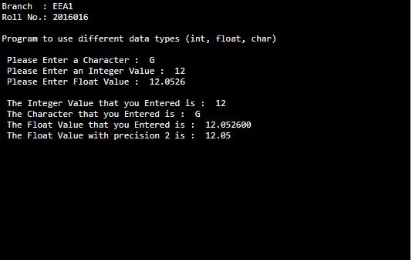**Output**

**Practical number - 3**

**Practical Name - Program to use arithmetic operators**

**Practical code**

# #include <stdio.h>

# int main()

# {

# int a, b, sum;

# a=12;

# b=25;

# sum=a+b;

# printf("Branch\t: EEA1 \nRoll No.: 2016016\n\n");

# printf("Program to use arithmetic operators\n\n");

# printf("Sum of two number %d + %d = %d",a, b, sum);

# return 0;

# }

# Output

# 

**Practical number -4**

**Practical Name - Program to use logical Operators**

**Practical Code**

#include <stdio.h>

int main()

{

int a = 5, b = 5, c = 10, result;

printf("Branch\t: EEA1 \nRoll No.: 2016016\n\n");

printf("Program to use logical Operators\n\n");

result = (a == b) && (c > b);

printf("(a == b) && (c > b) is %d \n", result);

result = (a == b) && (c < b);

printf("(a == b) && (c < b) is %d \n", result);

result = (a == b) || (c < b);

printf("(a == b) || (c < b) is %d \n", result);

result = (a != b) || (c < b);

printf("(a != b) || (c < b) is %d \n", result);

result = !(a != b);

printf("!(a != b) is %d \n", result);

result = !(a == b);

printf("!(a == b) is %d \n", result);

return 0;

}

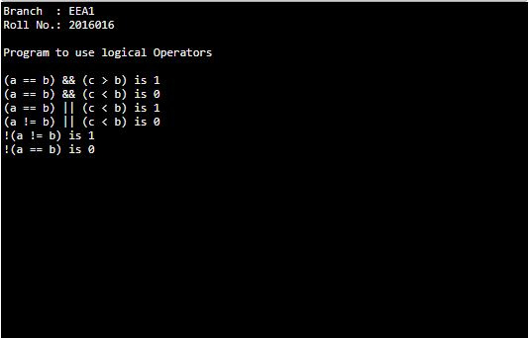**Output**

**Practical number -5**

**Practical Name - Program to use Relational Operators**

**Practical Code**

#include <stdio.h>

int main()

{

int a = 5, b = 5, c = 10;

printf("Branch\t: EEA1 \nRoll No.: 2016016\n\n");

printf("Program to use relational operators\n\n");

printf("%d == %d is %d \n", a, b, a == b);

printf("%d == %d is %d \n", a, c, a == c);

printf("%d > %d is %d \n", a, b, a > b);

printf("%d > %d is %d \n", a, c, a > c);

printf("%d < %d is %d \n", a, b, a < b);

printf("%d < %d is %d \n", a, c, a < c);

printf("%d != %d is %d \n", a, b, a != b);

printf("%d != %d is %d \n", a, c, a != c);

printf("%d >= %d is %d \n", a, b, a >= b);

printf("%d >= %d is %d \n", a, c, a >= c);

printf("%d <= %d is %d \n", a, b, a <= b);

printf("%d <= %d is %d \n", a, c, a <= c);

return 0;

}

**Output**

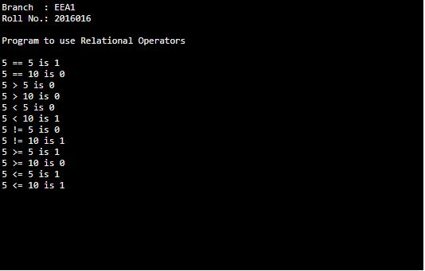

**Practical number -6**

**Practical Name - Program to use Increment and Decrement Operators**

**Practical Code**

#include<stdio.h>

int main()

{

int x = 12, y = 1;

printf("Branch\t: EEA1 \nRoll No.: 2016016\n\n");

printf("Program to use increment & decrement operators\n\n");

printf("Initial value of x = %d\n", x);

printf("Initial value of y = %d\n\n", y);

y = ++x;

printf("After incrementing by 1: x = %d\n", x);

printf("y = %d\n\n", y);

y = --x;

printf("After decrementing by 1: x = %d\n", x);

printf("y = %d\n\n", y);

return 0;

}

**Output**

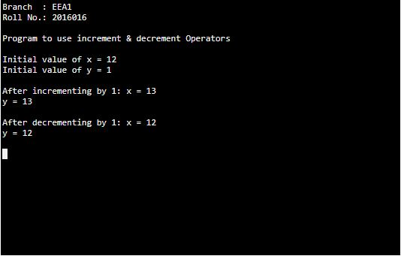

**Practical number -7**

**Practical Name - Program to use If-else, If else ladder**

**Practical Code**

#include<stdio.h>

int main()

{

int a,b,c;

printf("Branch\t: EEA1 \nRoll No.: 2016016\n\n");

printf("Program to use If-else, If else ladder\n\n");

printf("Enter three numbers: \n");

scanf("%d%d%d", &a, &b, &c);

if(a>b && a>c)

{

printf("Largest = %d", a);

}

else if(b>a && b>c)

{

printf("Largest = %d", b);

}

else

{

printf("Largest = %d", c);

}

return (0);

}

**Output**

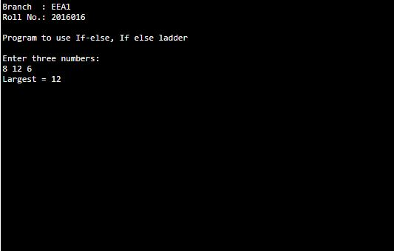

**Practical number -8**

**Practical Name - Program to use for loop, nested for loop**

**Practical Code**

#include <stdio.h>

int main () {

int i, j;

printf("Branch\t: EEA1 \nRoll No.: 2016016\n\n");

printf("Program to use for loop, nested for loop\n\n");

for(i = 2; i<100; i++)

{

for(j = 2; j <= (i/j); j++)

if(!(i%j)) break; // if factor found, not prime

if(j > (i/j)) printf("%d is prime\n", i);

}

return 0;

}

**Output**

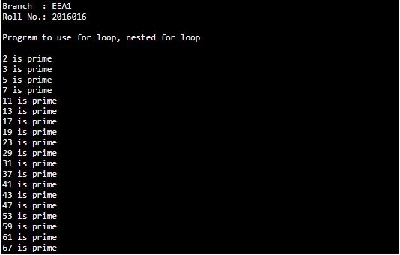

**Practical number -9**

**Practical Name - Program to use while loop, do while loop**

**Practical Code**

// Program to add numbers until the user enters zero

#include <stdio.h>

int main()

{

double number, sum = 0;

printf("Branch\t: EEA1 \nRoll No.: 2016016\n\n");

printf("Program to use while loop, do while loop\n\n");

// the body of the loop is executed at least once

do

{

printf("Enter a number: ");

scanf("%lf", &number);

sum += number;

}

while(number != 0.0);

printf("Sum = %.2lf",sum);

return 0;

}

**Output**

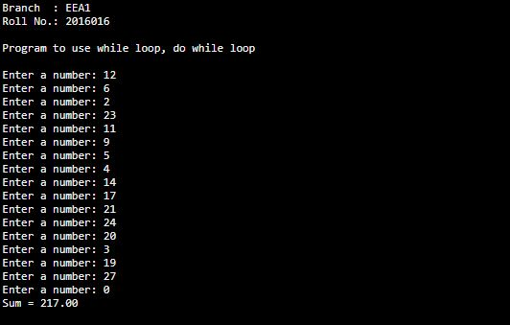

**Practical number -10**

**Practical Name - Program to use switch (Break & Continue)**

**Practical Code**

// Program to calculate the sum of numbers (10 numbers max)

// If the user enters a negative number, the loop terminates

#include <stdio.h>

int main() {

int i;

double number, sum = 0.0;

printf("Branch\t: EEA1 \nRoll No.: 2016016\n\n");

printf("Program to use switch (Break & Continue)\n\n");

for (i = 1; i <= 10; ++i) {

printf("Enter a n%d: ", i);

scanf("%lf", &number);

// if the user enters a negative number, break the loop

if (number < 0.0) {

break;

}

sum += number; // sum = sum + number;

}

printf("Sum = %.2lf", sum);

return 0;

}

**Output**

**Calculate the sum of numbers (10 numbers max)**

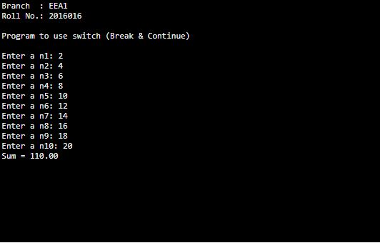

**Negative number terminates the loop**

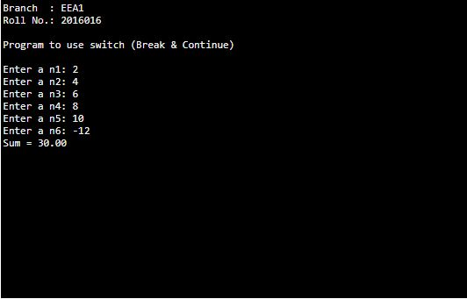

**Practical number -11**

**Practical Name –** **Program to implement & use functions**

**Practical Code**

#include<stdio.h>

void swap(int a, int b);

int main()

{

int m = 22, n = 44;

printf("Branch\t: EEA1 \nRoll No.: 2016016\n\n");

printf("Program to implement & use functions\n\n");

// calling swap function by value

printf(" values before swap m = %d \nand n = %d", m, n);

swap(m, n);

}

void swap(int a, int b)

{

int tmp;

tmp = a;

a = b;

b = tmp;

printf(" \nvalues after swap m = %d\n and n = %d", a, b);

}

**Output**

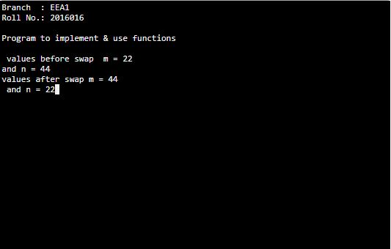

**Practical number -12**

**Practical Name –Program to use array**

**Practical Code**

// Program to take 5 values from the user and store them in an array

#include <stdio.h>

int main() {

int values[5];

printf("Branch\t: EEA1 \nRoll No.: 2016016\n\n");

printf("Program to use array\n\n");

printf("Enter 5 integers: ");

// taking input and storing it in an array

for(int i = 0; i < 5; ++i) {

scanf("%d", &values[i]);

}

printf("Displaying integers: ");

// printing elements of an array

for(int i = 0; i < 5; ++i) {

printf("%d\n", values[i]);

}

return 0;

}

**Output**

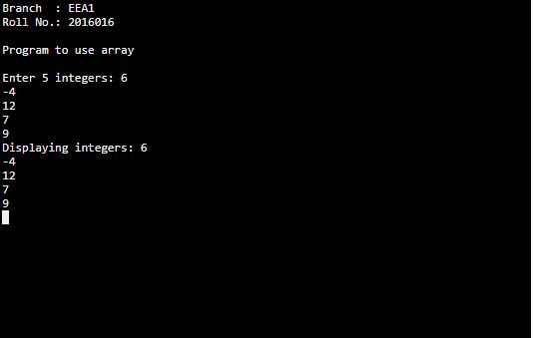

**Practical number -13**

**Practical Name - Program to Using structures**

**Practical Code**

#include <stdio.h>

struct student

{

char name[50];

int roll;

float marks;

};

int main()

{

printf("Branch\t: EEA1 \nRoll No.: 2016016\n\n");

printf("Program to use structures\n\n");

struct student s;

printf("Enter The Information of Students\n\n");

printf("Enter Name : ");

scanf("%s",s.name);

printf("Enter Roll No. : ");

scanf("%d",&s.roll);

printf("Enter marks : ");

scanf("%f",&s.marks);

printf("\nDisplaying Information\n");

printf("Name: %s\n",s.name);

printf("Roll: %d\n",s.roll);

printf("Marks: %.2f\n",s.marks);

return 0;

}

**Output**

